Tab 1

HoneyPot Farm & ELK Integration

Overview
This project is based on a network of decoy systems (honeypot) to capture real time attacker data and forward that data to an ELK(Elastisearch , Logstash , Kibana) to visualize attacker behavior.

It is similar with Deception Technology, a core components modern, higher-maturity
SOCs. It shifts focus from just watching alerts to actively hunting and analyzing attacker TTPs (Tactics, Techniques, and Procedures).

Technical Stack
- Honeypot Engine: Cowrie (SSH/Telnet honeypot) or Dionaea (captures malware).
Nozomi Networks
- Infrastructure: Docker containers (for easy cleanup and isolation).
- Data Pipeline: Filebeat (to collect logs) -> Logstash (to parse logs) -> Elasticsearch (to store data).
- Visualization: Kibana (to create threat maps and command dashboards).

Phase I :
Note : If you don’t have key then first generate the key by following command :
Command : gpg --full-generate-key
After generating key run the following command :
Command : pass init <your-generated-key>

Containerized Deployment
Deploying Cowrie by using Docker on ubuntu :
Command : docker pull cowrie/cowrie
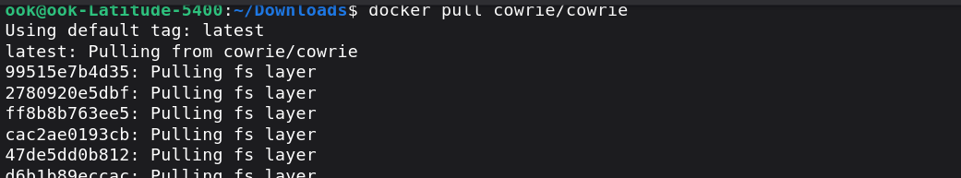
To use the Cowrie in Interactive mode run the following command :
Command : docker run -d -p 8000:8000 -p 9000:9000 \
-v /var/run/docker.sock:/var/run/docker.sock \
portainer/portainer-ce
docker run — Creates and starts a new container

-d — Run in detached mode (background). The container runs and you get your terminal back immediately instead of seeing live output.

-p 8000:8000 — Publish port 8000. Maps port 8000 on your host machine to port 8000 inside the container. You'll access Portainer's edge agent on http://localhost:8000.

-p 9000:9000 — Publish port 9000. Maps port 9000 on your host to port 9000 in the container. This is the main Portainer web UI you'll use at http://localhost:9000.

-v /var/run/docker.sock:/var/run/docker.sock — Mount a volume. This binds the Docker daemon socket from your host machine (/var/run/docker.sock) into the container at the same path. This lets Portainer communicate with Docker on your host—essentially giving the container permission to control Docker. Without this, Portainer couldn't manage your containers.

portainer/portainer-ce — The image to run. portainer-ce is the Community Edition (free, open-source).

After running this command run navigate to the web browser and enter :
URL : http://localhost:9000
The following interface comes :
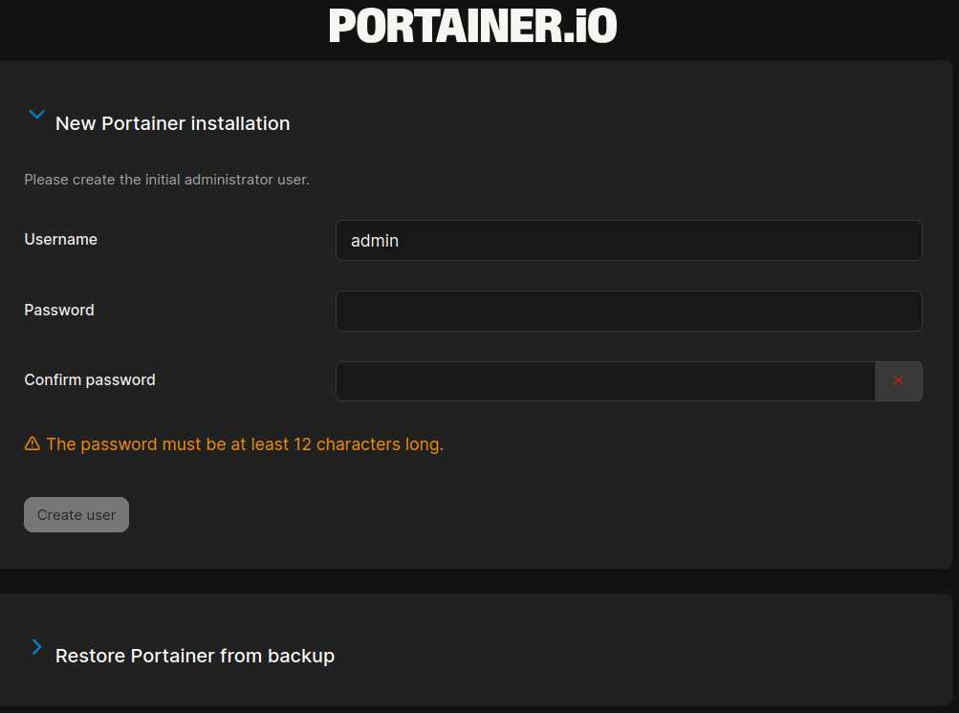
Set your password and Press Create user.
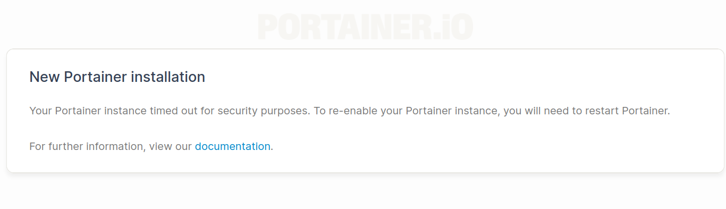
Now restart your Portainer
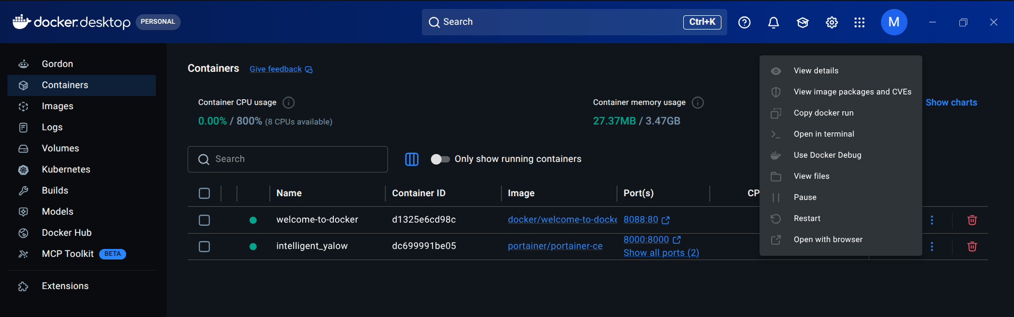

Click on restart. After restart it go back to the browser and the following interface shown to enter Username and Password :
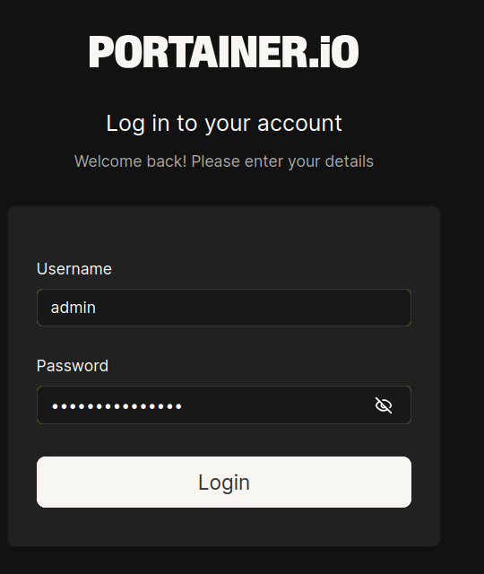
And press login.
After login it directs you to the Home page.

Deploying Cowrie via Portainer

Navigate to the "Containers" Section
- On the left-hand sidebar in your Portainer dashboard, click on Containers.
- Click the + Add container button.

Configure the Container
- Name: Give it a clear name, for example: cowrie-honeypot.
- Image: In the Image field, type: cowrie/cowrie:latest.
  - Note: Portainer will automatically pull this image from Docker Hub when you click "Deploy."
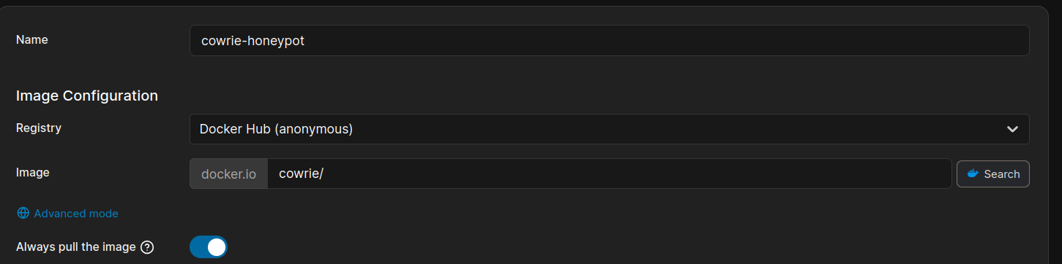

Map Network Ports
- Scroll down to the Network ports configuration section.
- Click + publish a new network port.
- Host: 2222
- Container: 2222
This maps the container's internal SSH port (2222) to your host machine's port (2222). When you (or an attacker) try to SSH into your machine on port 2222, it will land inside your Cowrie honeypot.

Set Restart Policy (Reliability)
- Under the Advanced container settings
- Select Always. This ensures that if the container crashes or the system reboots, the honeypot starts back up automatically.
- Access Container Settings :
- Click + map additional volume.
- Container: Type /cowrie/cowrie-git/var/log/cowrie/
- Host: Type /home/”your-username”/.cowrie-logs

Deploy

Click the Deploy the container button at the bottom of the page.
- The portainer will now download the image and start the container. This may take a minute or two.

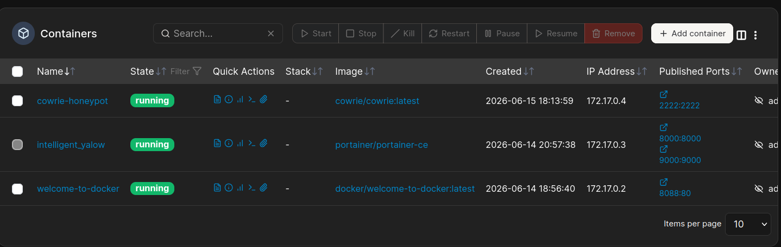
The Status ensures that the cowrie-honeypot is running. Now that the honeypot is live.

Phase II :

Verifying :
First of all create a directory which already have mentioned for host (i.e., /home/”your-username”/.cowrie-logs)
Command : mkdir 777 -p /home/”your-username”/.cowrie-logs

Create a fake login :
Try this command for fake login :
Command : ssh root@127.0.0.1 -p 2222
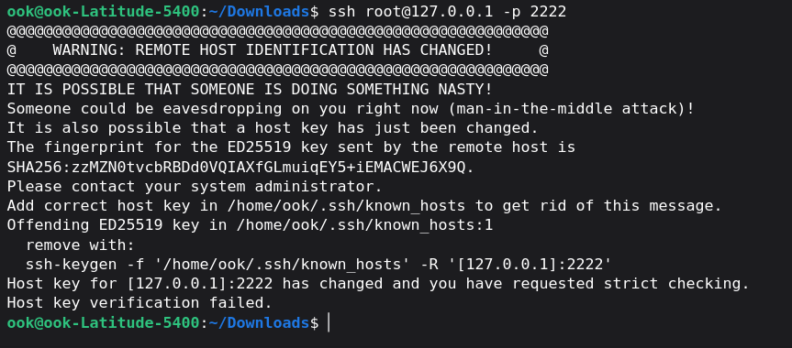

If you are seeing this prompt it is good news your system thinks that is a MITM and stops the connection immediately.
So what you need to do run the following command :
Command : ssh-keygen -f '/home/ook/.ssh/known_hosts' -R '[127.0.0.1]:2222'
Now enter the fake login command again :
Command : ssh root@127.0.0.1 -p 2222
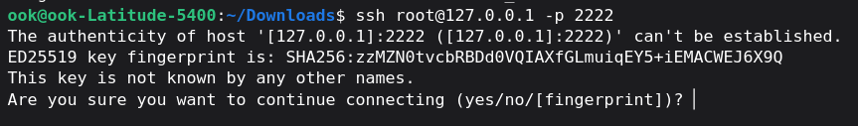
Type : yes and enter the fake password.
Once you try to log in, Cowrie will instantly create the log files. Type exit to disconnect, and then check the hidden folder one more time:
Command : ls -la /home/ook/.cowrie-logs
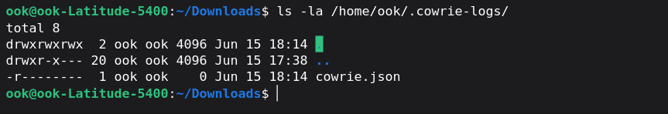
Look at the permissions the cowrie.json file has. It has only ready only permission we need to change these permissions write the following command :
Command : sudo chmod 666 /home/ook/.cowrie-logs/cowrie.json

Log Pipeline Setup (Filebeat & Elasticsearch Integration)
Because we are creating this project on ubuntu. We need to install & configure Filebeat on the ubuntu machine.

Step 1: Install Filebeat on Ubuntu
Run these commands in your Ubuntu terminal to download and install Filebeat:
Command : wget -qO - https://artifacts.elastic.co/GPG-KEY-elasticsearch | sudo gpg --dearmor -o /usr/share/keyrings/elastic-keyring.gpg
echo "deb [signed-by=/usr/share/keyrings/elastic-keyring.gpg] https://artifacts.elastic.co/packages/8.x/apt stable main" | sudo tee /etc/apt/sources.list.d/elastic-8.x.list
sudo apt-get update && sudo apt-get install filebeat
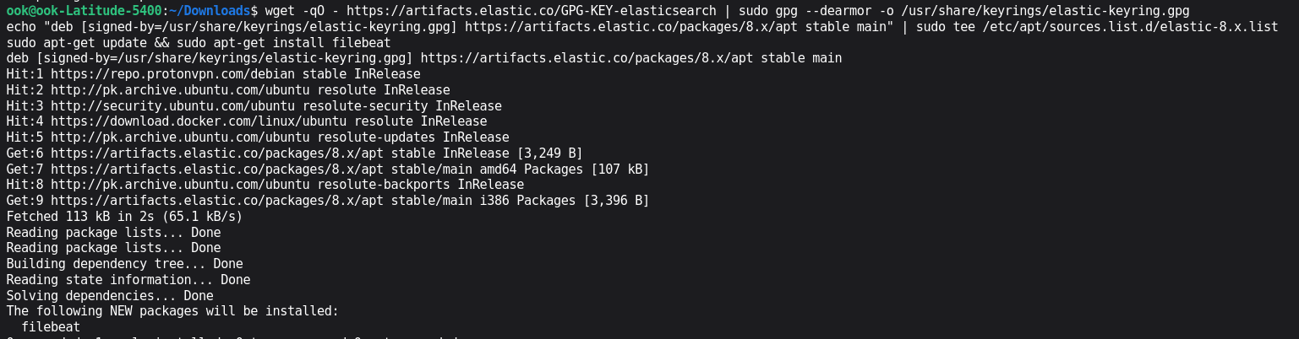

Step 2 Enable Filebeat to Boot on Startup
To enable the filebeat use the following command :
Command : sudo systemctl enable filebeat

Step 3 Configuring Filebeat
- Open the Filebeat Configuration File
Since this is a system configuration file, we need administrator privileges to edit it. Open it using the nano text editor by running this command :
Command : sudo nano /etc/filebeat/filebeat.yml
- Configure the log file Input Path
Find the filebeat.input section. We need to change the filebeat path and direct it to our hidden file (.cowrie-logs)
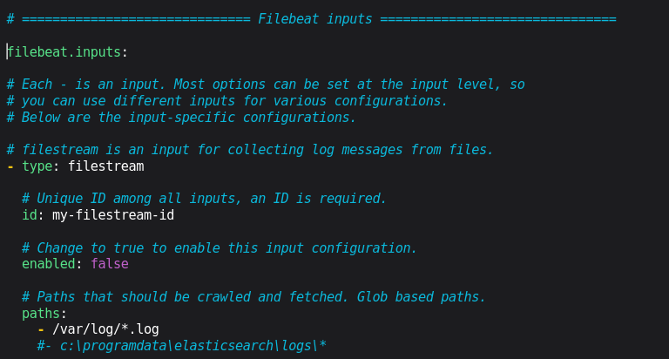
Modern versions of Filebeat use filestream as the default input type rather than the older log type, which is perfectly fine.
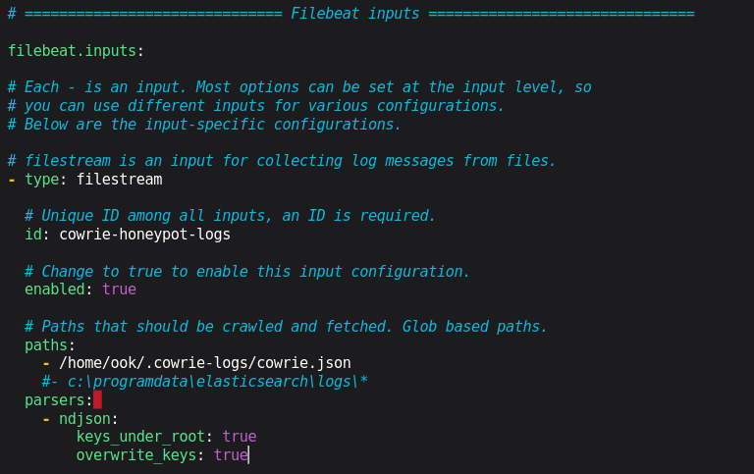
then save it (CTRL+O, Enter, CTRL+X).
- Restart Filebeat
Restart the filebeat to apply the changes that we made in it.
Command : sudo systemctl restart filebeat
If the terminal empty returns then it means changes are successfully applied.
- Downloading Elastisearch
Run the following command to Download elasticsearch
Command : sudo apt install elasticsearch
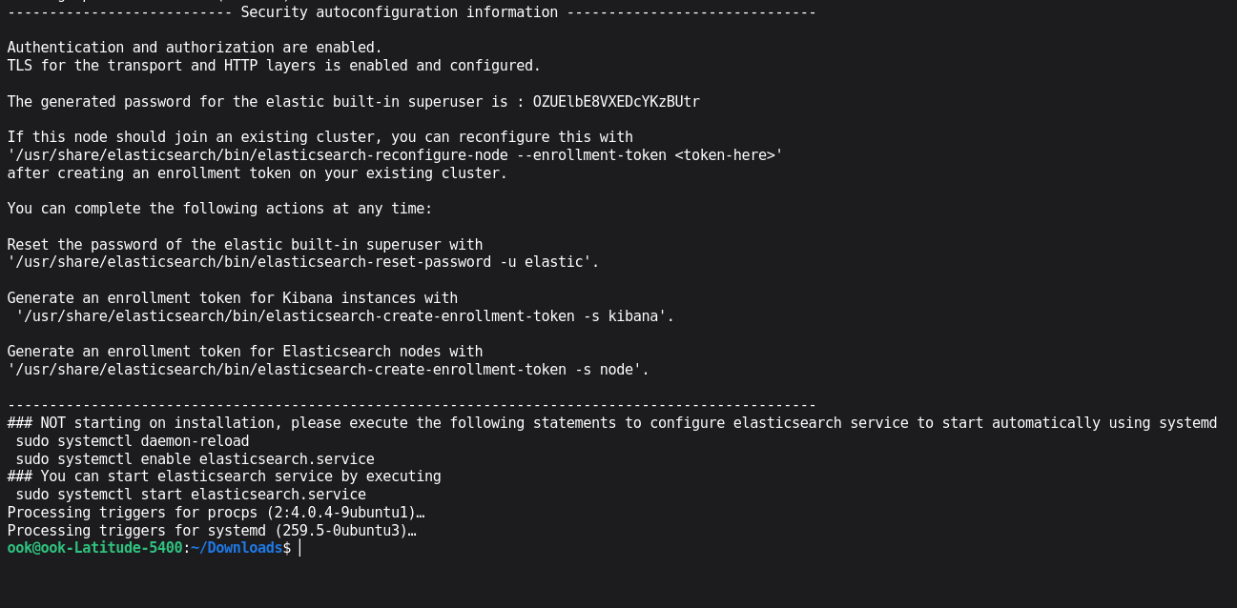
Note : Save the Elasticsearch Password into your file. We will use it later!!!
After installation Completed run the following commands :
Command : sudo systemctl daemon-reload
sudo systemctl enable elasticsearch.service
sudo systemctl start elasticsearch.service
If you saw this kind of error during the start of elasticsearch then follow the following steps otherwise move to the next step.
- Create an Options Modification File
Instead of editing the core configuration files directly, it is best practice to create a small override file inside the jvm.options.d directory. Open a new file using nano
Command : sudo nano /etc/elasticsearch/jvm.options.d/memory.options
- Add the Memory Constraints
Type or paste the following configuration lines into the file. This tells Elasticsearch to start with 1 GB of RAM and cap its maximum consumption at 2 GB:
Past : -Xms1g
-Xms2g
Save the file (Press Ctrl+O Enter , Ctrl+X)
- Restart , Start and Status of Elasticsearch
Command : sudo systemctl restart elasticsearch
sudo systemctl start elasticsearch
sudo systemctl status elasticsearch
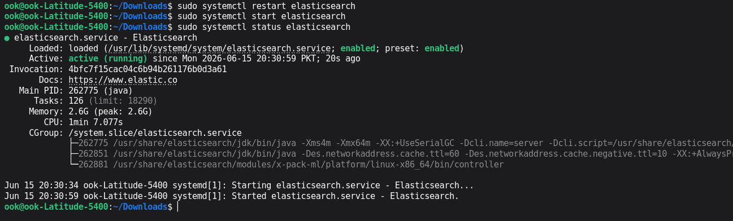
- Changing the filebeat configuration file for Elasticsearch
Write the following command in the terminal :
Command : sudo nano /etc/filebeat/filebeat.yml
Find Elasticsearch Output
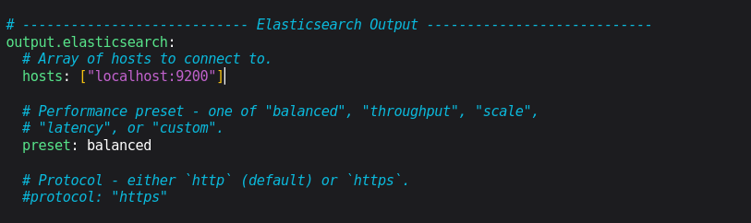
Remove the hosts and past the following lines :
hosts: ["https://localhost:9200"]
username: "elastic"
password: "Elasticsearch-password"
ssl.verification_mode: "none"
Note : Enter the Password which I said to save after the elasticsearch installation is completed.
Always after changing restart the filebeat
Command : sudo systemctl restart filebeat
Test that does filebeat is working perfectly or not use this command
Command : sudo filebeat test output

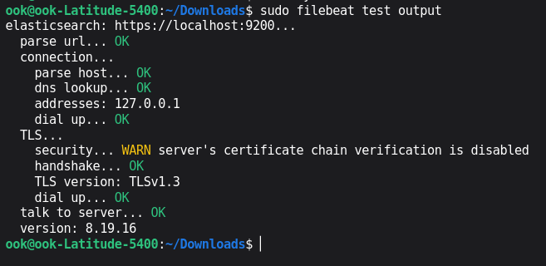

Phase III

Elasticsearch Indexing
The connection is active.
Now first do some activity run the following command :
Command : ssh wronguser@127.0.0.1 -p 2222
When it say for password to you then enter wrong password (mrsonic)
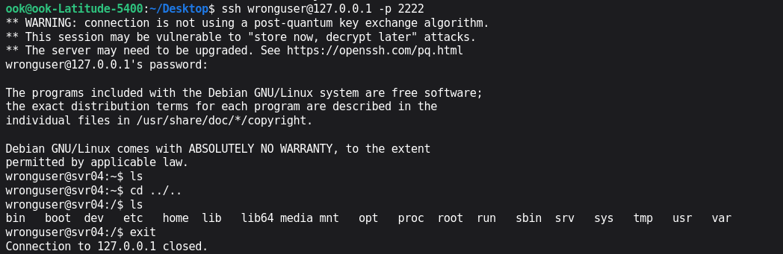
Now we need to check whether elasticsearch has begun indexing to cowrie logs or not. Run the following command :
Command : curl -k -u elastic -X GET “https://localhost:9200/_cat/indies?v”
added -k to tell curl to ignore the self-signed certificate warning, and -u elastic so it prompts for password.
Type Elastic Password :
Now enter the elastic password which we have saved after the installation of elasticsearch is completed.
Now the data is indexed, the next step of Phase III is learning to read and search specific parameters (like Attacker IPs , used passwords and typed commands ) using elasticsearch queries.

Lets try to extract the password that we have typed during the honeypot test. Run the following json query in the terminal.
Command : curl -k -u elastic -X GET "https://localhost:9200/.ds-filebeat-8.19.16-2026.06.17-000001/_search?pretty" -H 'Content-Type: application/json' -d'
{
"_source": ["eventid", "src_ip", "message"],
"query": {
"match": {
"eventid": "cowrie.command.input"
}
}
}'
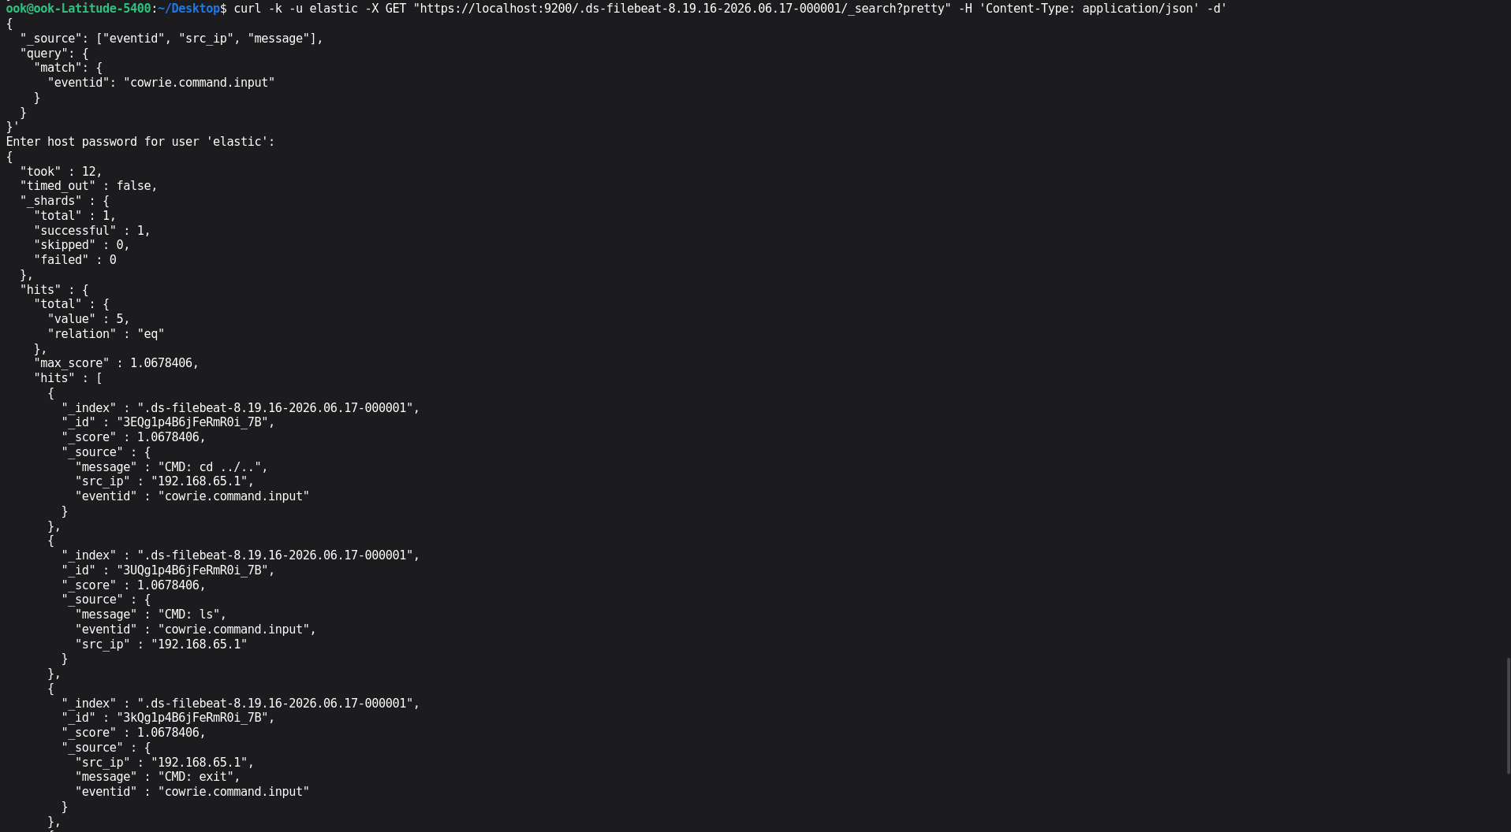
Here are some commands which are shown. It means our honeypot is ready now we just need to visualise data.
So that is why we are installing Kibana. (Kibana is described in the kibana documentation file. So, check it out first).

Phase IV

Kibana Installation
To install kibana by terminal run the command :
Command : sudo apt install kibana
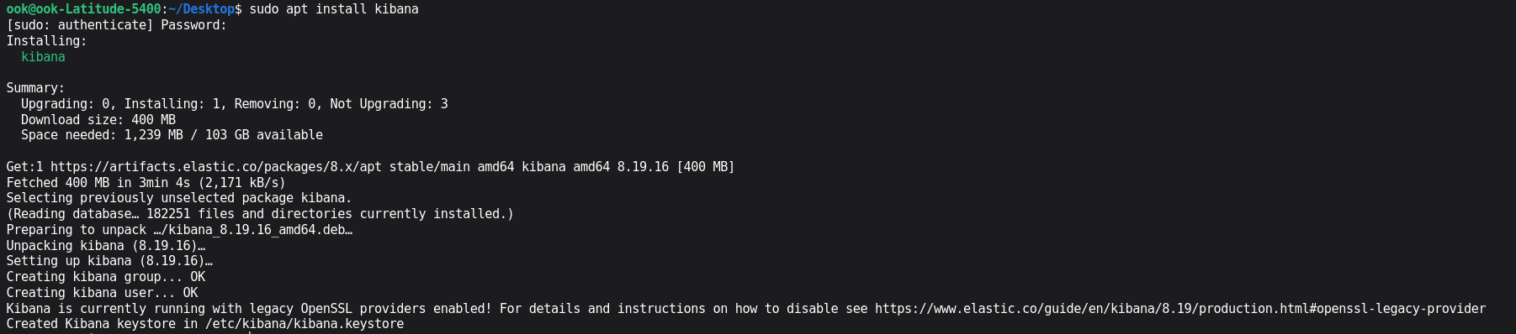
Once the installation finishes , run the following command to start , enable and check the status of kibana :
Command : sudo systemctl start kibana && sudo systemctl enable kibana && sudo systemctl status kibana
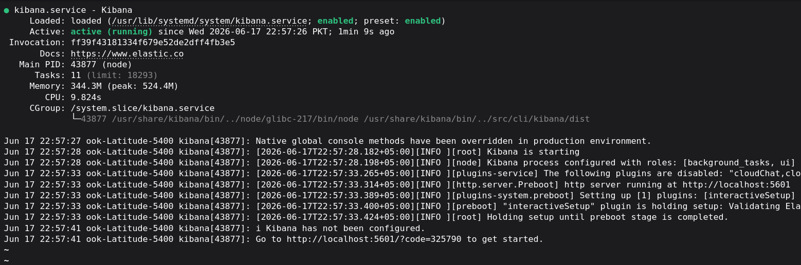

Open Kibana in Your Browser
Look closely at the last line of kibana status Go to http://localhost:5601/?code=325790 to get started. Kibana has automatically generated links for us. Let's use it. Go to the browser and run the given link.
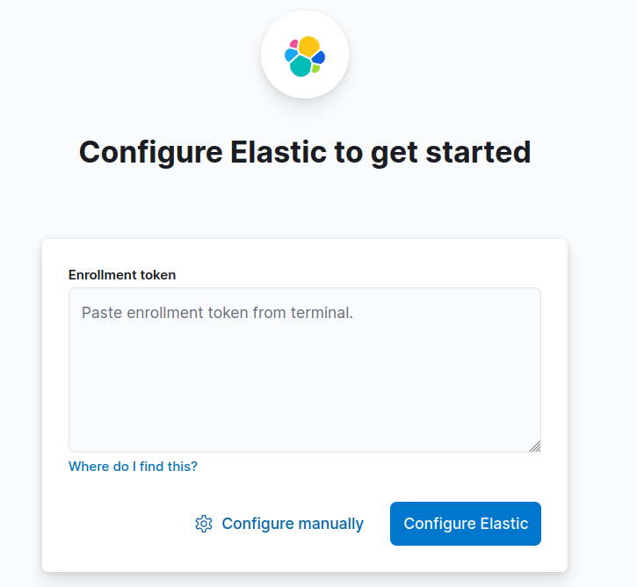
Here kibana is asking as for the token to configure the Elastic run the following command to generate the token :
Command : sudo /usr/share/elasticsearch/bin/elasticsearch-create-enrollment-token -s kibana

Generate an Elasticsearch Enrollment Token
Note : here is a twist when we installed the elasticsearch if you know that we also have done some security configuration by TLSv1.3 and its session uses a cipher suite (TLS_AES_256_GCM_SHA384). The certificate includes several Subject Alternative Names. So, it’s very important to remain yourself in the same network for this honeypot.
If you do not then this time when you want the token for kibana to configure the elasticsearch becomes not possible. So, make sure of your availability.
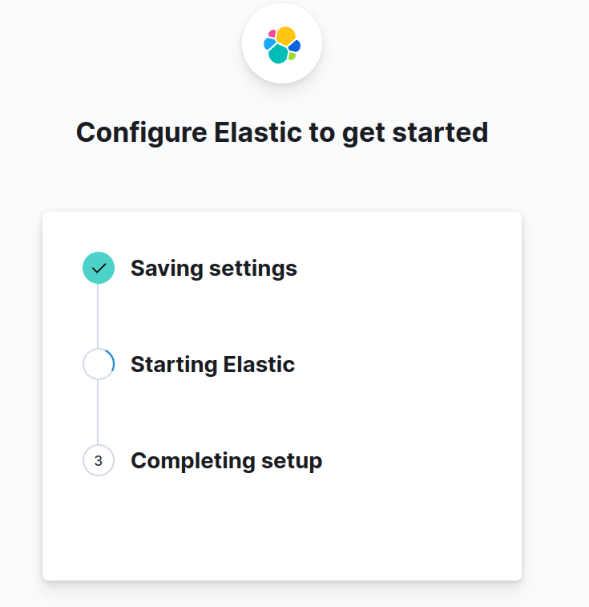
After that’s completed. The next login page comes to enter your elastic username and password.
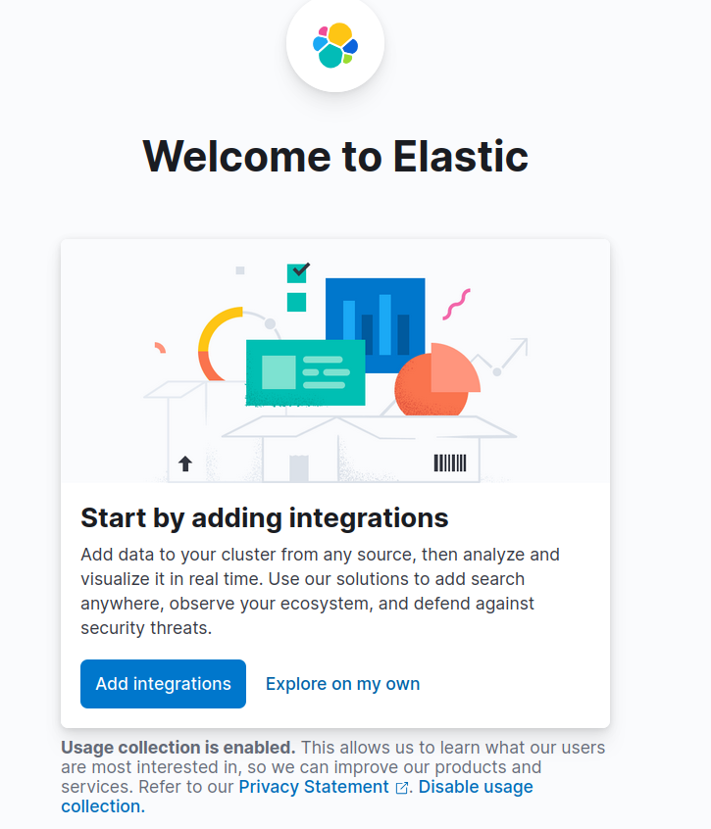

Click on Explore on my own
The following home page will comes :

Click on three lines and navigate to Stack Management
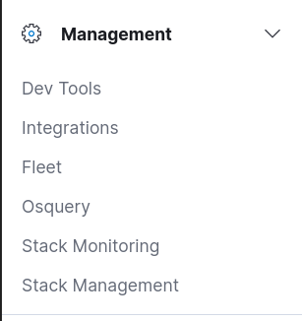
Then on the next page left side scroll down and find Data Views
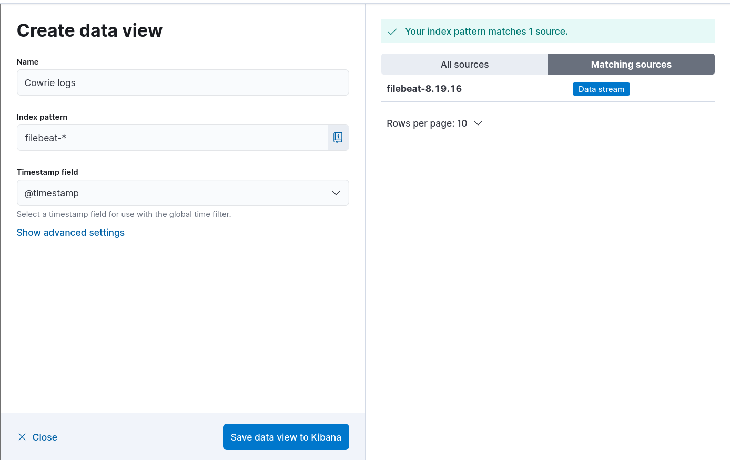
Click on create a data view
Set name = Cowrie logs
Index pattern = filebeat-* (it can automatically match it)
Timestamp Field = @timestamp
Then click on save data view to kibana

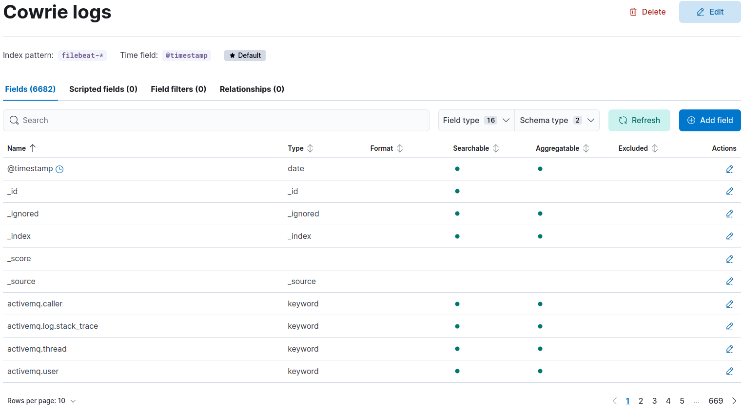

Now after that select the Discover option from the top left panel.
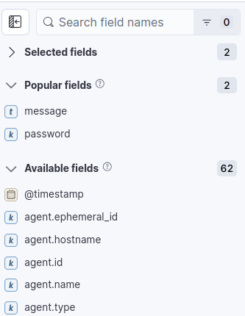
In this given search field search :
- Password
- Message
And drag them one by one to the main field
To arrange all the process step by step go to the Sort field and select timestamp

As shown in the screenshot

Now you can visualise every process step by step that what the hacker does step by step from last to end :
